**LAB NAME : AI ASSISTED CODING**

**LAB NUMBER :01**

**ROLL NO :2503A51L46**

**BRANCH : CSE**

**NAME :M. Sravan kumar**

**TASK 1**

* **TASK DESCRIPTION:** Write a comment: # Function to check if a string is a valid palindrome (ignoring spaces and case) and allow Copilot to complete it.

**PROMPT:** Generate a Python function to check if a string is a valid palindrome, ignoring spaces and case.

**CODE:**

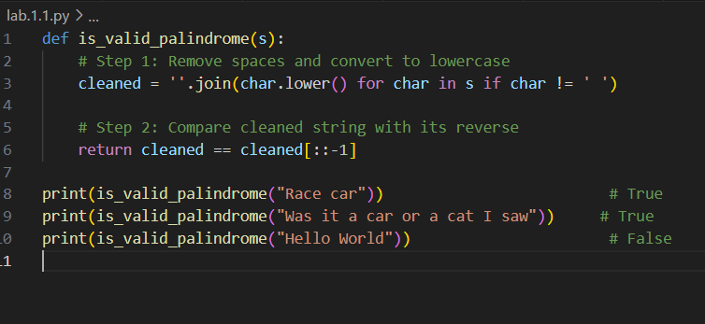

**OUTPUT:**

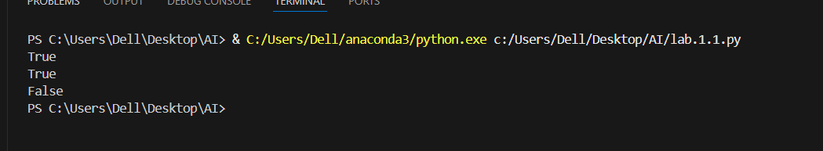

**TASK 2**

* **TASK DESCRIPTION:** Generate a Python function that returns the Fibonacci sequence up to n terms. Prompt with only a function header and docstring.

**PROMPT:** Write a Python function that returns the Fibonacci sequence up to n terms. Include only the function header and a descriptive docstring.

**CODE:**

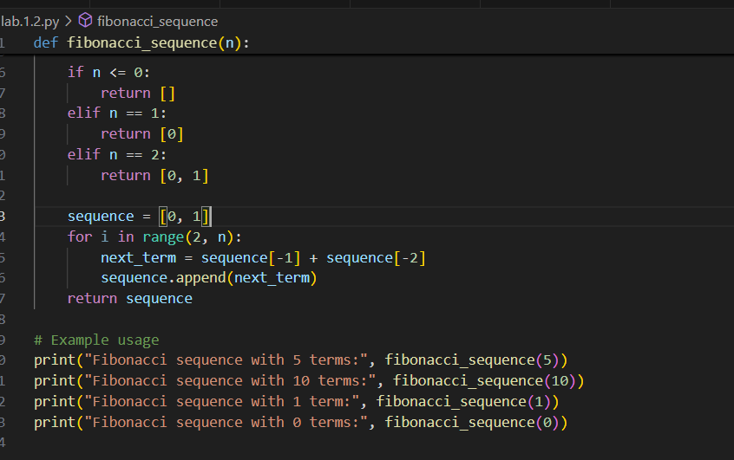

**OUTPUT:**

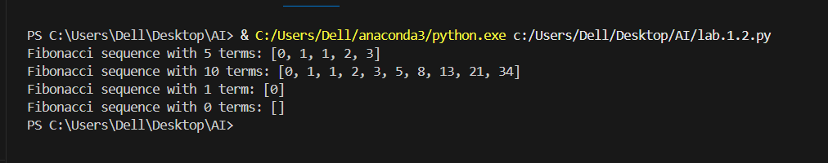

**TASK 3**

**Task Description:** Write a comment like # Function to reverse a string and use Copilot to generate the function.

**Prompt:** Generate a Python function with type hints that takes a string as input and returns the reversed string.

**CODE:**

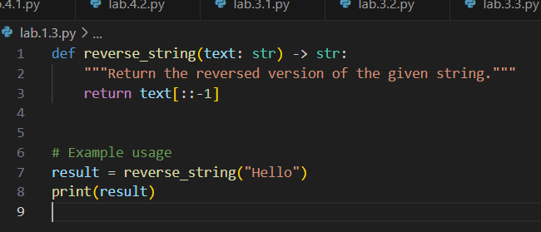

**OUTPUT:**

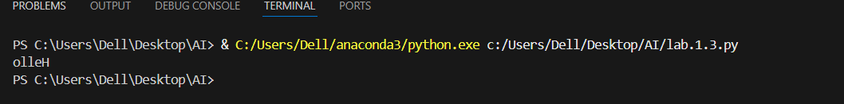

**TASK 4**

**Task Description:** Generate a program that simulates a basic calculator (add, subtract, multiply, divide). Write the comment: # Simple calculator with 4 operations and let AI complete it.

**PROMPT:** Generate a Python program that takes two numbers as input and performs addition, subtraction, multiplication, and division.

**CODE:**

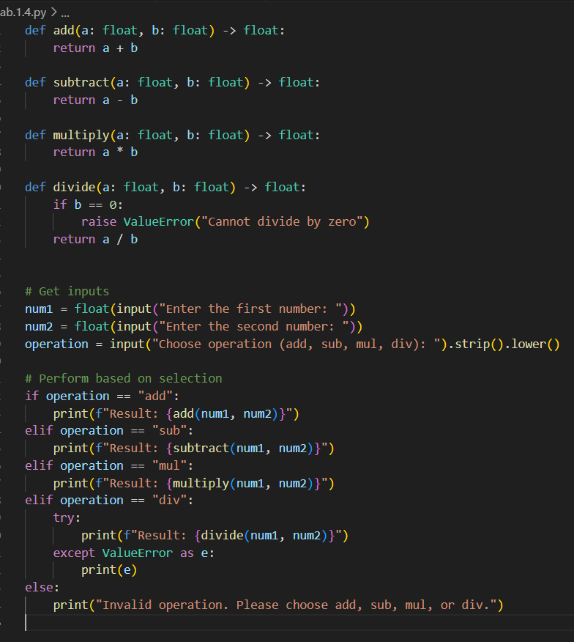

**OUTPUT:**

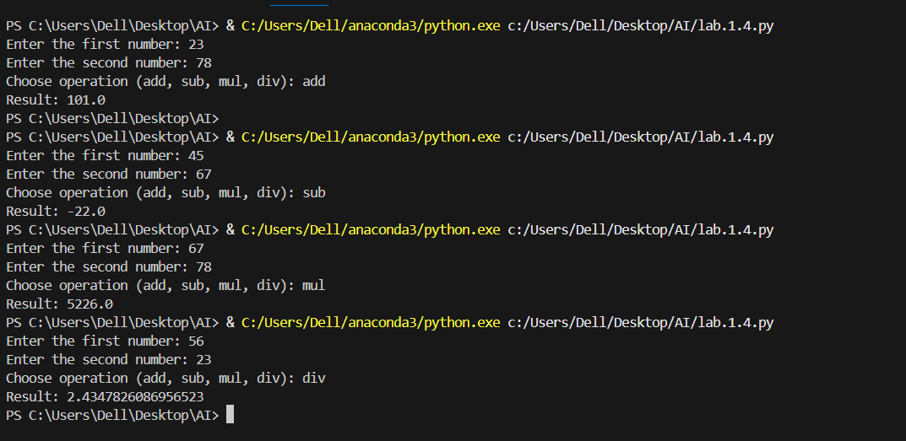

**TASK 5**

**Task Description:** Use a comment to instruct AI to write a function that reads a file and returns the number of lines...

**PROMPT:** Generate a Python function that opens a file, counts how many lines it contains, and returns that number.

**CODE:**

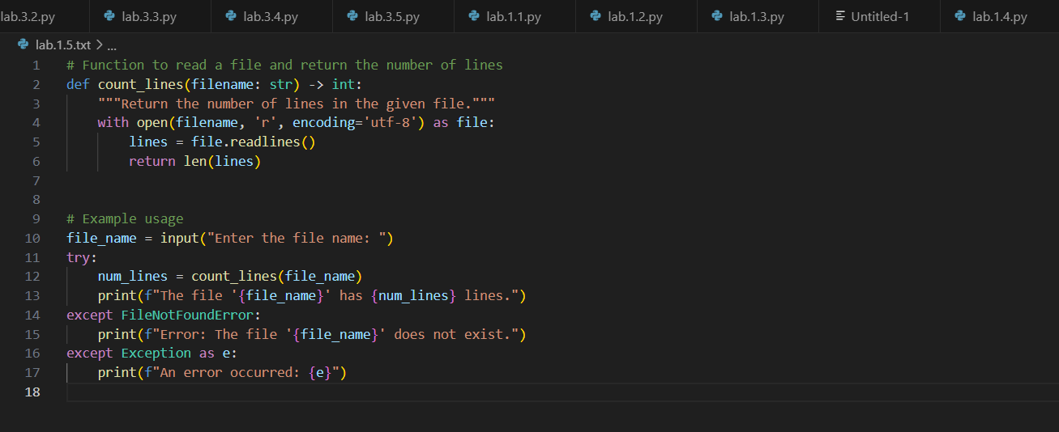

**OUTPUT:**

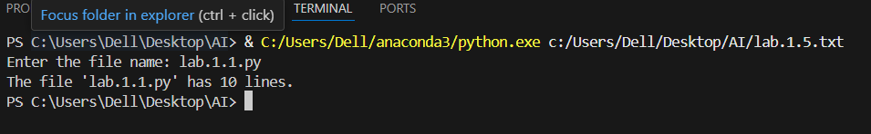

**OBSERVATION: I observed that GitHub copilot can quickly generate working code for tasks such as login systems, loan approvals, Fibonacci functions, and job applicant scoring. However, the generated code sometimes contains issues like hardcoded values, lack of encryption, or biased decision logic. This shows that AI tools are helpful for faster coding but require human review for security, fairness, and correctness.** **GitHub Copilot is a fascinating tool to observe—especially in how it transforms the developer experience. Here's a breakdown of key observations across its functionality, impact, and adoption**